|  |  |
| --- | --- |
| Krishna Kanth B | invoice |
| Old: 24/1, New 47  Govindappa Naicken Street,  George Town, Chennai  India 600001 | **INVOICE** #001  **DATE 19/Sep/2024** |
| TO  Katy Ward  Alloy.dev  3131 Western Ave, Site 527,  Seattle, Washington, zip code 98121  United States  accounting@amplenote.com |  |

|  |  |
| --- | --- |
| Description | Amount |
| Metadata Plugin | $500/- |
|  |  |
|  |  |
|  |  |
| **Total** | $500/- |
|  | (Five Hundred Dollars Only/-) |
|  |  |

If you have any questions concerning this invoice, contact

Krishna Kanth B,

[kkvitbiotech@gmail.com](mailto:kkvitbiotech@gmail.com),

(+91)7667360114

(P.T.O.) For further details.

Requirements:

<https://amplenoteplugins.featureupvote.com/suggestions/501807/generate-a-note-that-is-a-categorized-directory-of-published-notes>

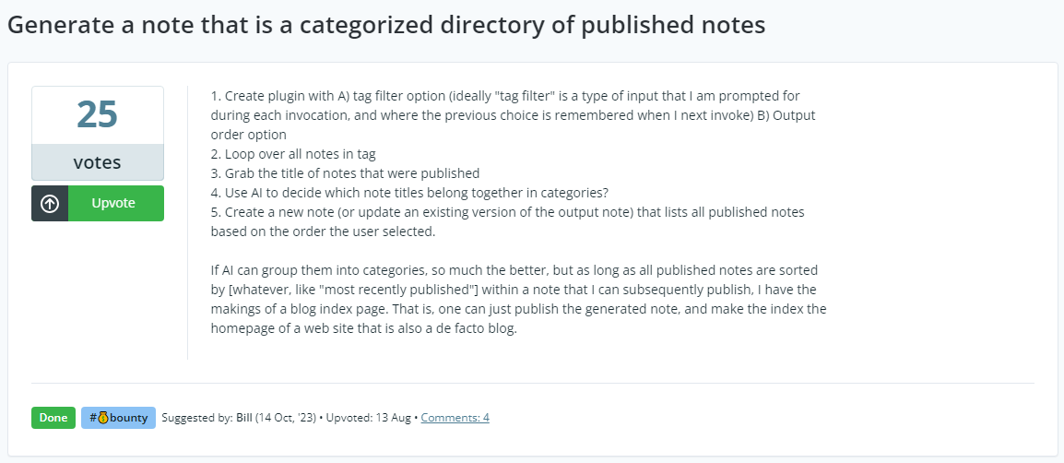

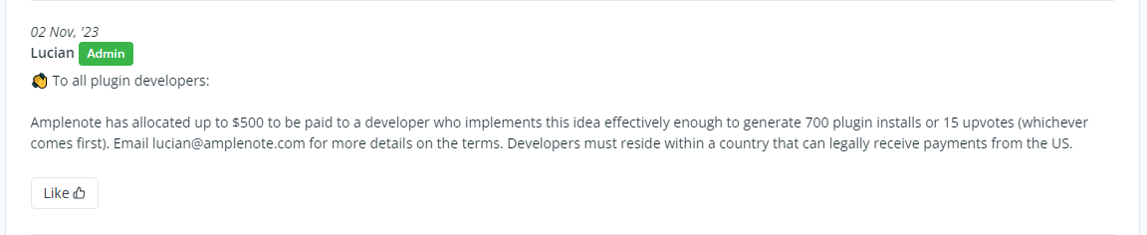

Published Plugin:

https://www.amplenote.com/plugins/WL34r5m5xnFX2C1bVcL7RypF

